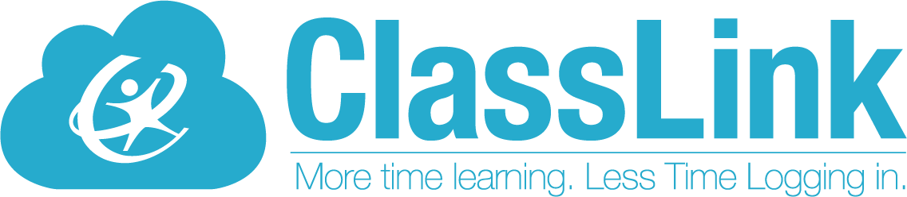

Single Sign-On technology allowing teachers and students

access to everything they need with just one login!

____________________________________________________________________________Dear Parents,

Your child’s school is now using ClassLink, a single sign-on platform that will allow teachers and students to use one username and password to access everything they need. Single sign-on is an essential tool for productive remote learning, and ClassLink will serve as your child’s homebase for education, whether it’s in the classroom or on the couch at home.

ClassLink can be accessed from either a computer or mobile device. Please follow the directions below to get started.

|  |  |
| --- | --- |
|  |  |
| **Here is how to help get your child started on a computer:**   1. Go to this website: <https://launchpad.classlink.com/dickinsonisd> 2. Enter your username and password 3. Follow the attached [tutorial](https://assets.website-files.com/5d6db64572061db9c481aaeb/5e81f6f107248f442c78e011_classlink-quickguide.pdf) ([Spanish](https://assets.website-files.com/5d6db64572061db9c481aaeb/5e8b2ee0ee4cf10f24dff8bc_classlink-quickguide-spanish.pdf)) (A message will prompt you to install an extension when accessing applications). | **Here is how to help get your child started on a mobile device:**   1. Download the appropriate app:   [**iOS**](https://itunes.apple.com/us/app/classlink-launchpad/id524297631?mt=8)  [**Google Play**](https://play.google.com/store/apps/details?id=com.classlink.launchpad.android&hl=en)  **\*Be sure not to use the mobile device’s browser and only these mobile app options.**   1. Click the arrow in the top right corner to search for and choose “Dickinson ISD” (one-time selection). 2. Enter your username and password 3. Follow the attached [tutorial](https://drive.google.com/file/d/1jWhl7p0MlOklg79KcxZV_psRCJn7B8Vf/view?usp=sharing). |
|
|

ClassLink is a safe and secure way to ensure your child has access to everything needed for continued learning. We want you to know our software never collects or shares any personal student information. Read more about our commitment to [privacy](http://classlink.com/privacy) here:

If you have questions, visit our [FAQ for home users,](https://support.classlink.com/hc/en-us/articles/360045364214-FAQ-for-Home-Users) or you can contact the school tech support team or email [Studenthelpdesk@dickinsonisd.org](mailto:Studenthelpdesk@dickinsonisd.org).

**Thank You!**